Patty

So I see Andrea Featherstone at SRX is the contact. I have not sent this to her direct as we are going thru you but we have a MAJOR issue with the changes made last night. They are noted below. We are at a stand still here

So we are requesting urgently that we have a Teams meeting with someone this AM on this. It would be Mike P, Jess and I and we are all free NOW thru the AM

So Saradex updated the ROL/ROQ last night. When I came in this AM there is nothing but 4 weird items up on MRP. Then I got to looking at a few very common, higher volume parts and 3 examples are below. All 3 have some common missing items but also all 3 have some weird stuff that was changed

EXAMPLE #1 – Missing “Location” and “Type” ticked box (gone) Also “Location” is incorrect – Was Raw Materials. Updated ROL and ROQ per attached sheet correct however on this one

ItemNo | Name | NEW ROL | NEW ROQ
08-00524 | K24 CAPITAL (356-1 Heat Treated T5) | 838.95 | 419.477431

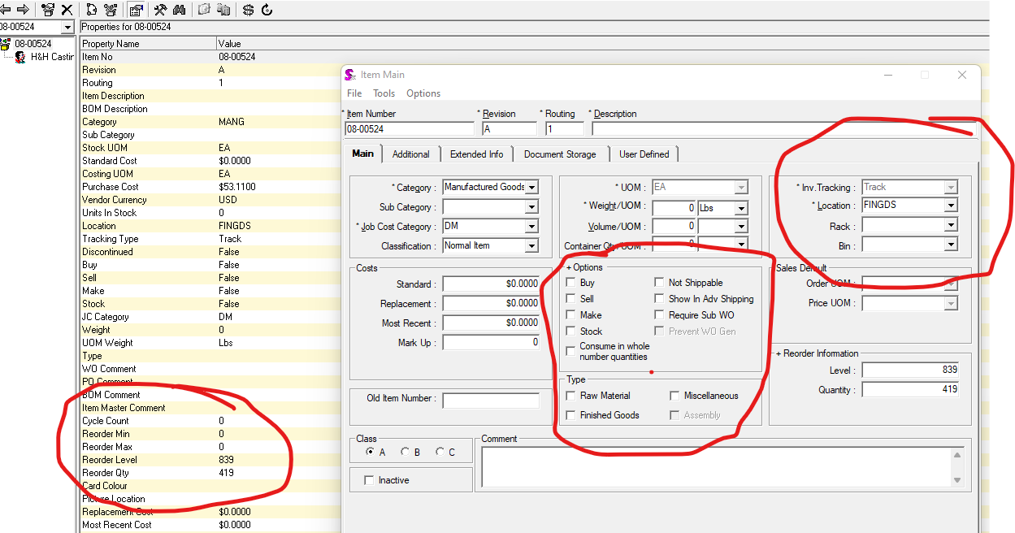

EXAMPLE #2 – Missing “Location” and “Type” ticked box (gone)– Updated ROL and ROQ per attached sheet Incorrect

ItemNo | Name | NEW ROL | NEW ROQ
03-80001 | P4 LEDIL OPTIC 2X2 T3C13301_STRADA-2X2-T3 | 32720 | 16360

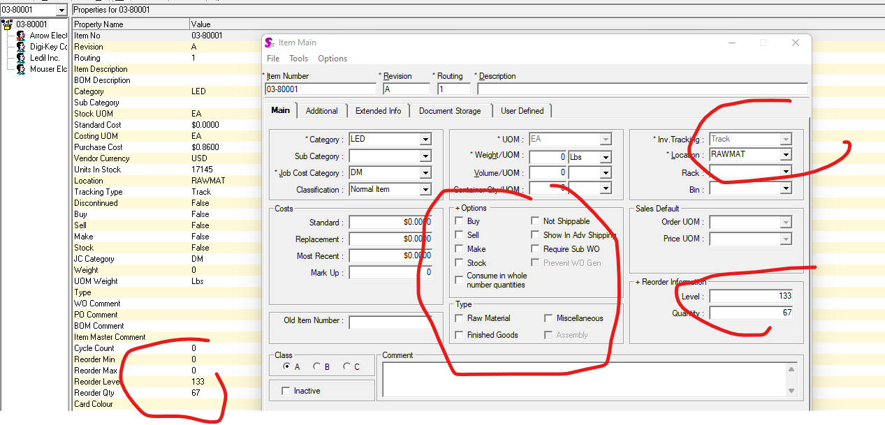

EXAMPLE #3 – Missing “Location” and “Type” ticked box (gone). Updated ROL and ROQ per attached sheet Incorrect – Also this one is missing the item description

ItemNo | Name | NEW ROL | NEW ROQ
04-30205 | WIRE NUT, CRIMPON TYPE#55929-1 | 30738 | 15369

